**SIMPLE INTEREST-CLASS**

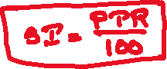

1. Find the simple interest on 7500/- in 4 years at 15% per annum.



1.3000 2.3600 3.4500 4.4800 5.5000

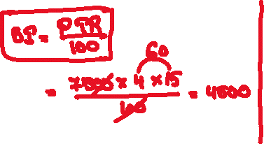

1. On what sum of money will the SI be 2000/- in 5 years at 8% per annum



1.4000 2.4500 3.4800 4.5000 5.6000

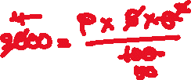

1. The SI on 6400/- at 12 ½ % per annum is 2000/-. Find the period



1.2yrs 2.2yrs 3mths 3.2yrs 6mths 4.3yrs 2mths 5.3yrs 6mths



1. The SI on 6000/- in 3yrs 4mths is 3000/-. Find the rate percent per annum



1.15 2.17.5 3.18 4.20 5.24

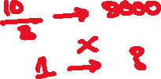

1. Arjun took a loan of 4000/- at SI. After 2 years he cleared the loan by paying 5600/-. Find the rate % p.a

1.12 2.12.5 3.15 4.18 5.20



1. Ravi took a loan of 12000/- at 12%p.a. Find the amount to be paid by him after 3 years at simple interest



1.4320 2.5600 3.17600 4.16320 5.8640

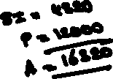

1. A man invested 20,000/- at 10% p.a, 15,000 at 12% p.a, and some money at 15% p.a. if the total annual interest received is 5,600/-. Find the money invested by him at 15% p.a.



1.10,000 2.12,000 3.12,500 4.18,000 5.14,000



1. On a sum of money, the rate of interest is 5% p.a for the first 3 years, 6% p.a for the next 4 years, and 8% p.a for the next years beyond the first 7 years. If the interest obtained in 12 years is 3,950/-. Find the sum



1.5000 2.6000 3.7200 4.8000 5.10000



1. A sum was put at a certain rate for 5 years. Had it been put at 3% p.a higher rate, it would have fetched 900/- more. Find the sum



1.4000 2.4500 3.5000 4.5400 5.6000



1. On a certain sum of money, the SI in 2 years at 10% p.a is 125/-. What would be the simple interest if the rate of interest will be 12% p.a in three years?



1.216 2.225 3.240 4.250 5.300



1. A lent 25000 to B for 4 years and 40000 to C for 3 ½ years and got 24000 SI from both cases. Find the rate p.c.p.a

1.9 2.10 3.12.5 4.15 5.18



1. What sum will amount to 1920/- in 4 years at 15% per annum simple interest?

1.1200 2.1250 3.1320 4.1400 5.1500



1. In how many years will a sum of money become double at 12 ½ % per annum simple interest?

1.6 2.8 3.10 4.12 5.14



1. A sum of money becomes double itself in 5 ½ years at simple interest. In how many years will it become thrice?

1.15 2.10 3.18 4.6 5.11

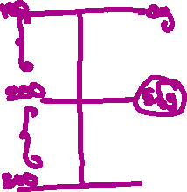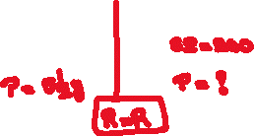

1. A man received 240/- as SI on 800/-for 6 years. If he expects 300/- as SI on 1200/-, for how many years should he keep the deposit?



1.4 2.4.5 3.5 4.7.5 5.15

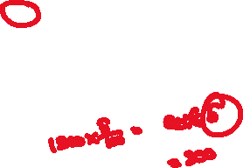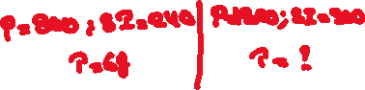

1. The SI on a sum of money is 9/16 of the principal and the rate p.c.p.a is the same as the number of years. Find the period in years



1.4 2.4.5 3.5 4.7.5 5.9

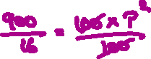

1. A certain sum amounts to 3120/- in 3 years and to 4080/- in 7 years. Find the rate p.c.p.a



1.9 2.10 3.12 4.15 5.16



1. A part of the sum of 3200/- was invested at 10% per annum and the rest at 12% p.a. The annual interest received was 360/-. Find the money lent at 10% per annum



1.1400 2.1800 3.1200 4.2000 5.2200



1. On what sum of money will the SI in 4 years at 7 ½ % p.a. be equal to the SI on 10,500/- in 5 years at 12% p.a?



1.5250 2.14000 3.18250 4.21000 5.14250



1. A sum of 8850/- is lent into 3 parts. The first is lent for 4 years at 6 ¼% p.a, the second for 5 years at 10% p.a and the third for 8 years at 12 ½ % p.a. Find the first part if the amounts in all three cases are the same.



1.2400 2.3000 3.3200 4.3750 5.3600



1. A man invested 50% of his investment at 20% p.a, 50% of the balance at 18% p.a, and the final balance at 16% p.a. What is the overall rate % p.a?



1.20.9 2.24.6 3.18.5 4.22.2 5.20.2



1. A man invested a part of his money at 20% p.a. and the balance at 30% p.a. If he had invested all the money at 30% p.a., he would have earned 1200/—more interest than before for 1 year. What is the sum invested at 20% p.a.?



1.12000 2.18000 3.24000 4. 16000 5. Can’t be determined



1. What equal annual payment will discharge a debt of 5800/- due in 5 years at 8% p.a simple interest?



1.1000 2.960 3.900 4.840 5.1200



1. A man deposited different amounts in two banks A and B which offer 20% p.a and 16% p.a SI. Later on, he realized that if he had exchanged the deposited amounts, he would have gotten 280 more per year. Find the money he deposited in bank A if the total interest earned was 10,120/- in one year.



1.24,000 2.25,000 3.30,000 4.32,000 5.35,000.



**\*\*\* All the best\*\*\***